Photos of the CNTM/ Força Sindical Solidarity demonstration at the turnstiles of GM Plant in Mogi das Cruzes, São Paulo, Brazil

Video subtitles:
We are in solidarity with the UAW in the United States for the initiative to make this demonstration against racism, and to say that we are also totally against racism. We would like to say that here in Brazil we are in solidarity with all the people of Brazil and the world against the racism. I would like to invite everyone to have a moment of silence for George Floyd.

Union Director David Martins and General Secretary Arakem - São Paulo Metalworkers' Union - CNTM/Força Sindical

Banner translation:
Black Lives Matter!
In Brazil, in the U.S. and all over the World.
Enough of racism, violence, prejudice, inequality and social injustice!

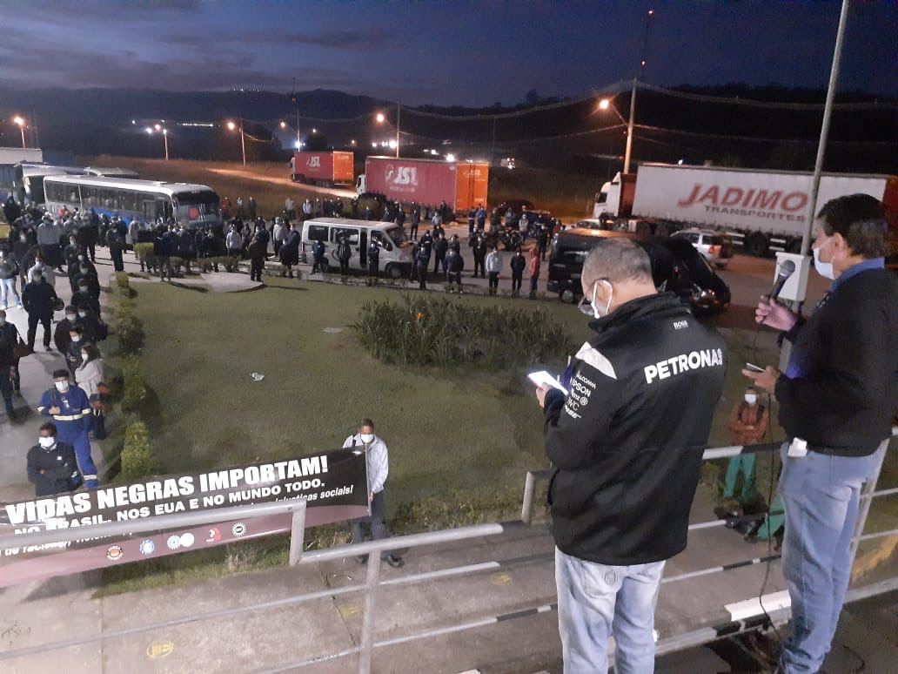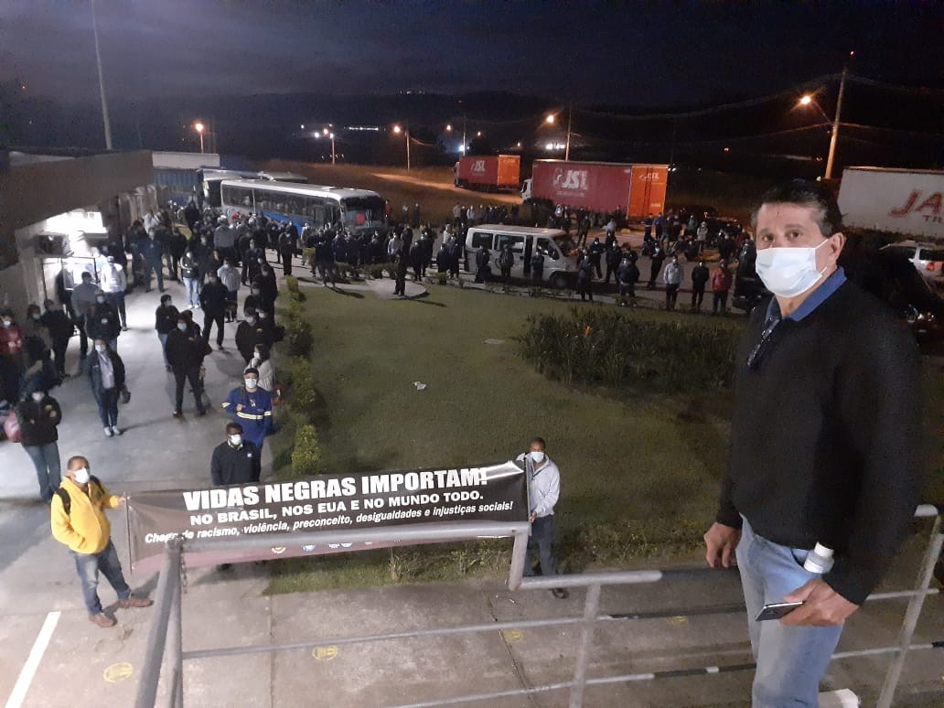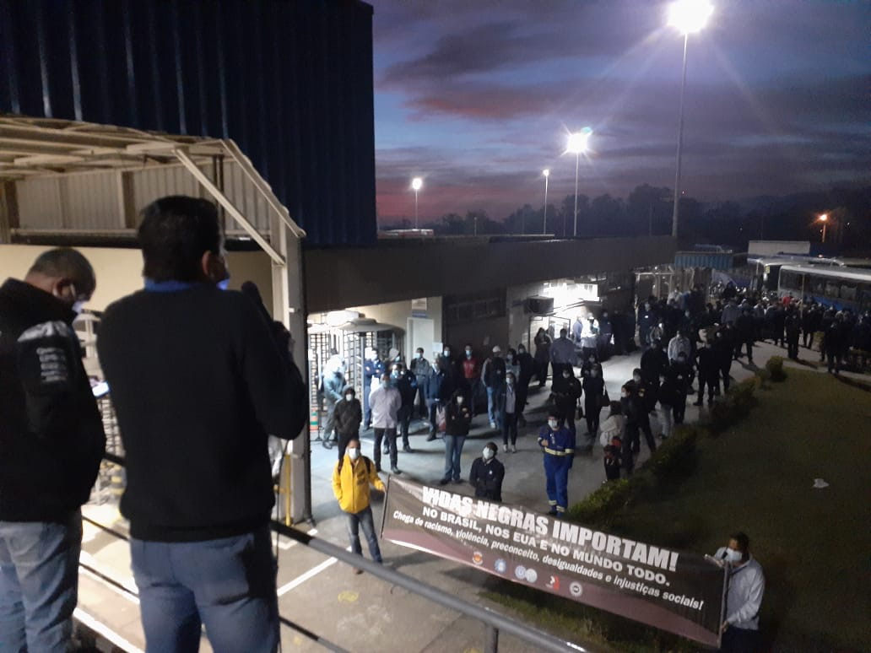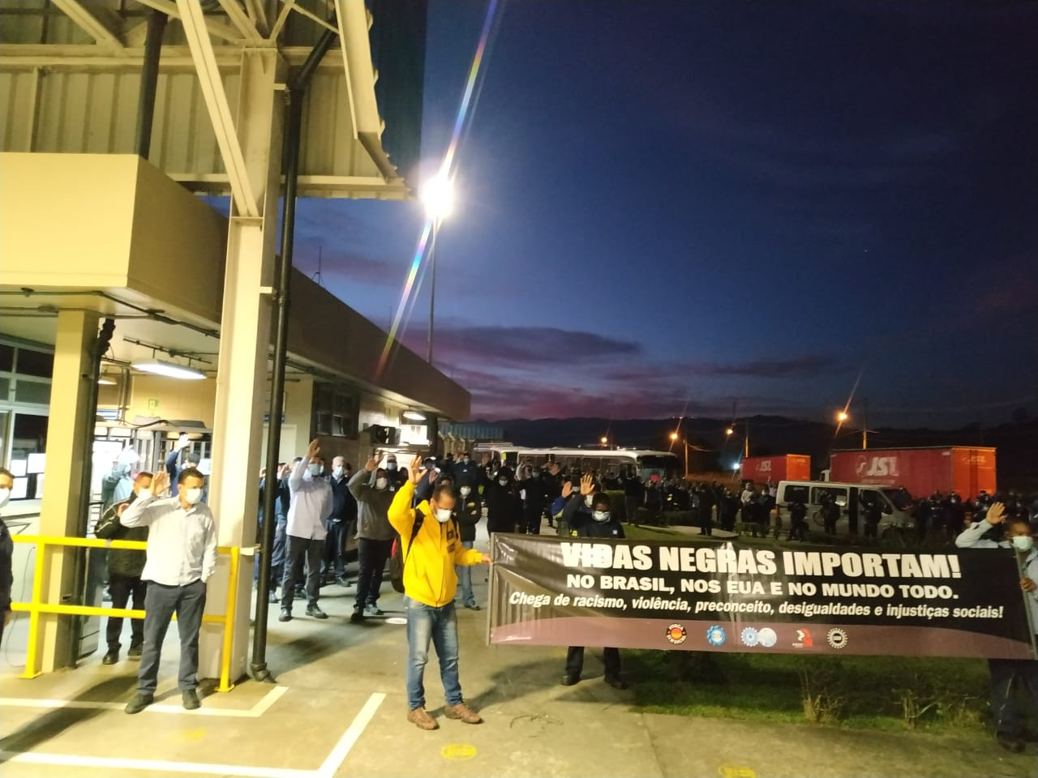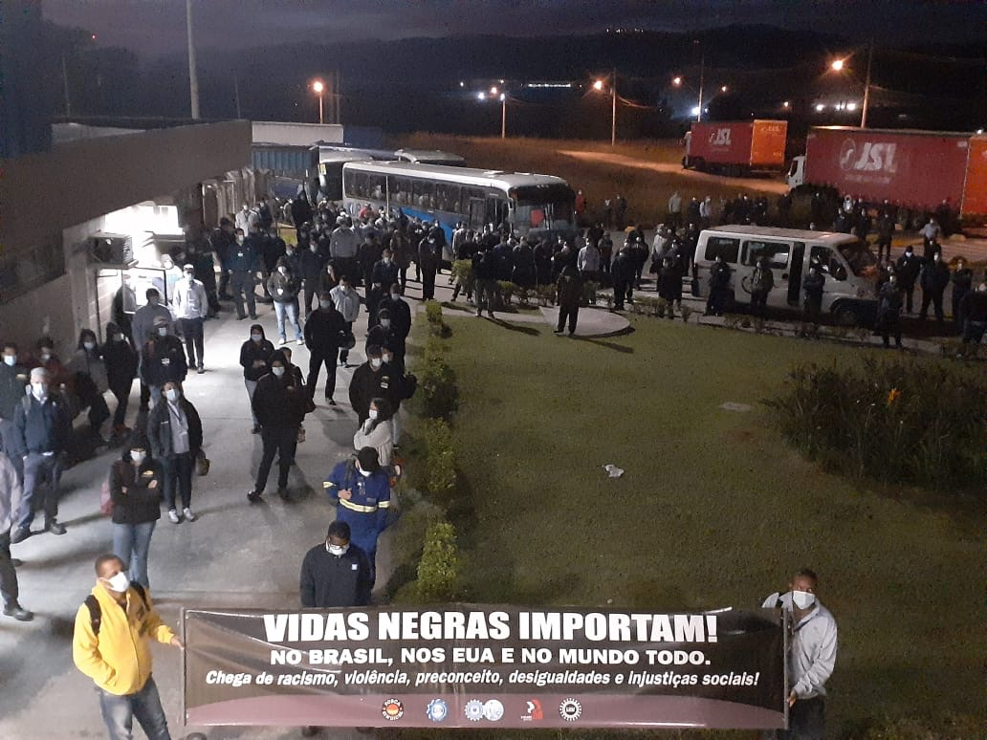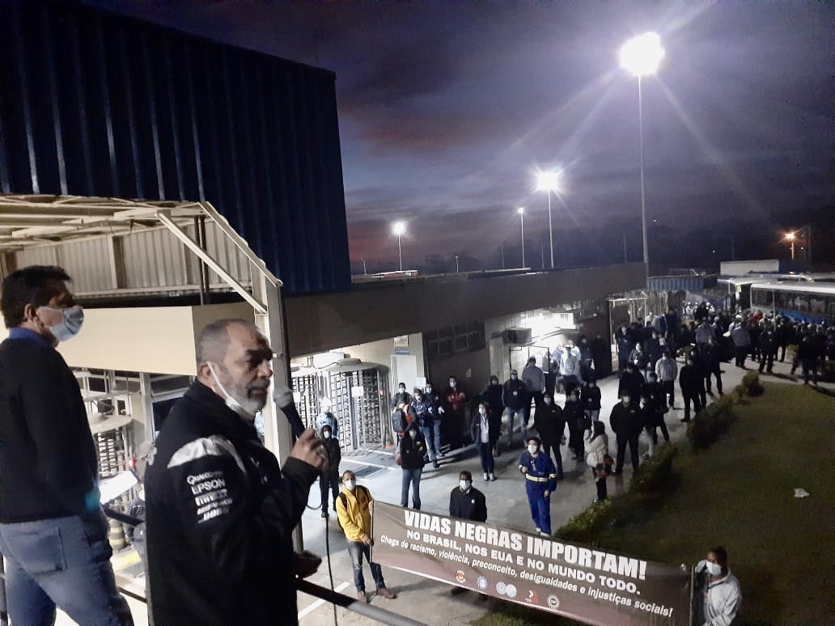

US metalworkers will stop in protest over George Floyd's death

The UAW (North American Metalworkers Union) shared a text to the metalworkers containing details for the acts to be carried out this Friday (19) due to the death of George Floyd on May 25.

by Fábio Casseb

The orientation is that, on Friday (19), at 8:46 am (in each time zone), UAW members and allies around the world take a break for 8 minutes and 46 seconds, time that George Floyd, agonizingly, he remained on an American street begging for his life. "We do this in support of the millions who demand an end to racism and hatred and call for real reforms," ​​says the document, signed by President Rory L. Gamble.

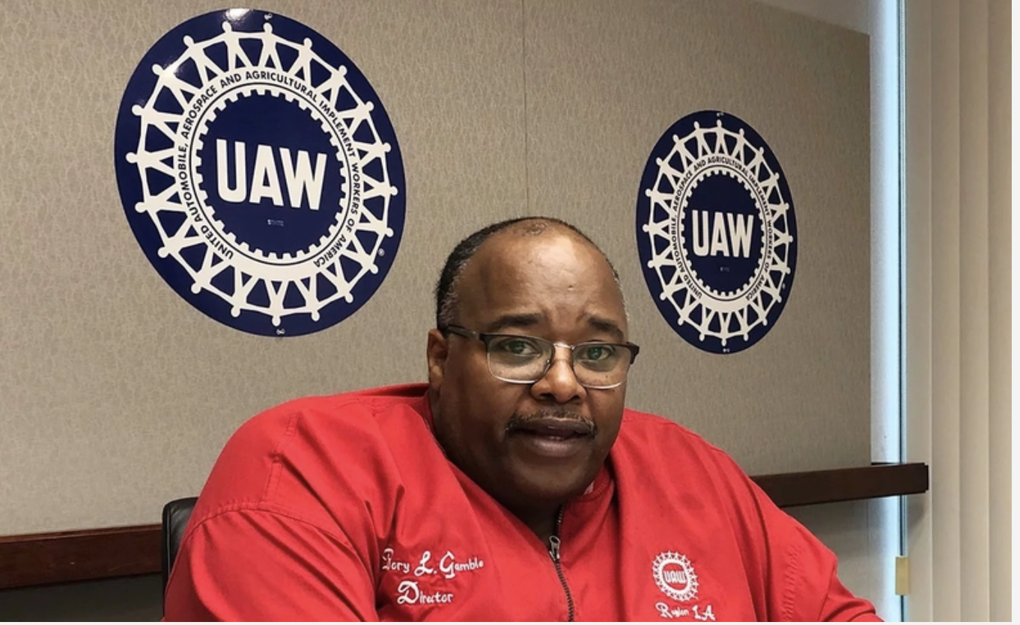

The president of Força Sindical, Miguel Torres, warns that the brutal murder of George Floyd was only the trigger, and one more episode of the historical series of violent and racist actions, committed by the security forces and the systems of repression in the USA, in a parents where racism, hatred and social injustice seem to be structured and institutionalized. "Racism, hatred and social injustice, play an insidious role in society, and are present in almost all environments, in the workplace and in the public and private sectors, in the vast majority of countries in the world, including Brazil" , recalls Torres.

The union leader who is also president of CNTM and the Metalworkers Union of São Paulo, Mogi and Great Region says that the anti-racist struggle of the Afro community and the majority of American society at this time, is also our struggle in Brazil. "The Brazilian union movement joins the fight for a more just society, free from racism and discrimination in the United States and in the world."

Paulo Cayres, president of the CUT National Confederation of Metalworkers (CNM / CUT), points out that the UAW must keep this fight against racism permanent. “This atrocity committed against our black brother cannot go unpunished, those responsible for this crime must be properly punished”, says the union leader.

The union leader recalls that here in Brazil, a young black man dies every 23 minutes. “The union movement has an important social role and we must mobilize to end racism in Brazil and in the world,” adds Cayres, who warns that governments like Trump's, in the USA and Bolsonaro, in Brazil, further promote racist practices, proliferating hatred and intolerance.

Rory Gamble points out that since the day of Floyd's assassination, it has been possible to see, in communities from coast to coast, Americans from all walks of life, blacks, browns and whites united to demand change. “We are outraged and very moved by Floyd's cowardly murder, which is yet another tragedy in a long and sad history of the division of racism in the United States. We want this systemic racial divide that has plagued our nation from the beginning to come to an end. ”

The text further highlights that the UAW leadership is working across the country to facilitate peaceful and orderly stops in the workplace. More than 150,000 workers are expected to stop their activities.

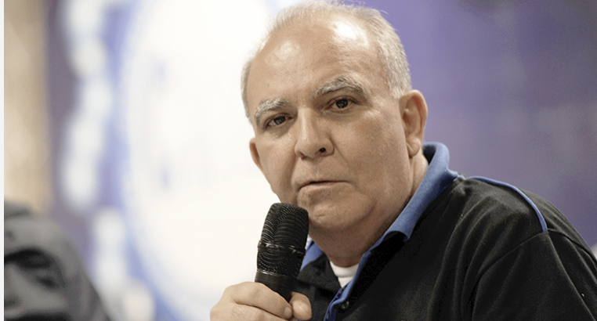
Miguel Torres (CNTM/Força Sindical) - “We must fight unitedly and in solidarity against all the serious Pandemics of humanity, not only the Pandemic of COVID 19, but the Pandemic of Racism, among others

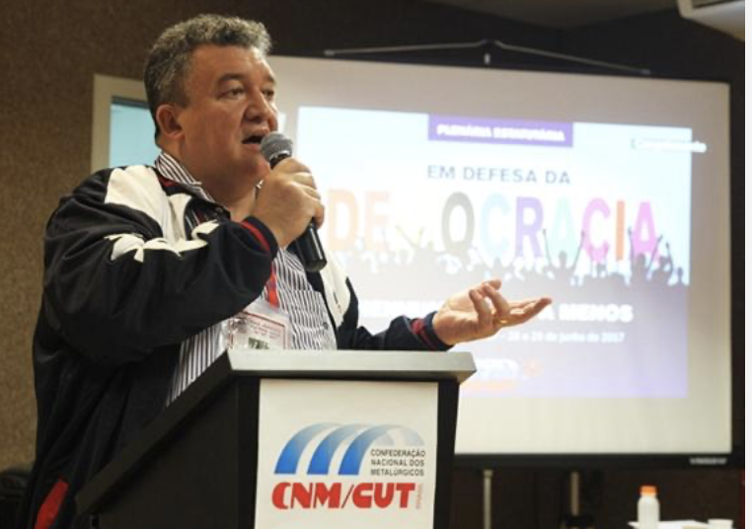
Paulo Cayres, president of CNM / CUT, defends the union movement to make a permanent fight against this atrocity that is racism

Source: https://radiopeaobrasil.com.br/metalurgicos-dos-eua-farao-paralisacao-em-protesto-por-morte-de-george-floyd/

GM union and workers from Mogi das Cruzes protest this Friday against racism

This Friday, June 19, the Metalworkers Union of São Paulo and Mogi das Cruzes, workers and General Motors will make a rally against racism, violence, prejudice, inequalities and social injustices.

The act will take place in front of GM, Avenida General Motors, 1.999, Taboão, Mogi das Cruzes, beginning at 6:00 am and minute of silence at 8:46 am on behalf of African American George Floyd, who died on May 25, after a white Minneapolis police officer kneeling on his neck for eight minutes and forty-six seconds while lying face down on the road.

This demonstration is worldwide and is being organized by UAW-United Auto Workers (Metalworkers Union of the United States and Canada). Click here and access the UAW communiqué.

“Expressions of hatred and crimes against black people and populations need to end, whether in Brazil, the United States and around the world,” says Miguel Torres, president of Força Sindical, CNTM and the Union of Metalworkers of São Paulo and Mogi das Cruzes, remembering that in Brazil racist attacks are very common in everyday life and in cases of greater public commotion such as the recent deaths of the boys Miguel, 5 years old, and João Pedro, 14 years old.

Source: http://cntm.org.br/sindicato-e-trabalhadores-da-gm-de-mogi-das-cruzes-protestam-nesta-sexta-contra-o-racismo/

Banner translation:

Black Lives Matter!
In Brazil, in the U.S. and in the World.
Enough of racism, violence, prejudice, inequality and social injustice!

